Required Resources
- 1 PC with operating system of your choice
- Virtual Box
- DEVASC Virtual Machine
- GNS3
- Internet connection

Device | Interface | IP Address
R1 | Fa0/0 | 192.168.1.1
 | S0/0 | 10.0.0.1
DEVASC-LABVM | Ethernet 0 | 192.168.1.2
PC2 (VPCS) | Ethernet 0 | 192.168.1.3
R2 | Fa0/0 | 192.168.2.1
 | S0/0 | 10.0.0.2
Ubuntu | Ethernet 0 | 192.168.2.3
PC1 (VPCS) | Ethernet 0 | 192.168.2.2

Network Topology
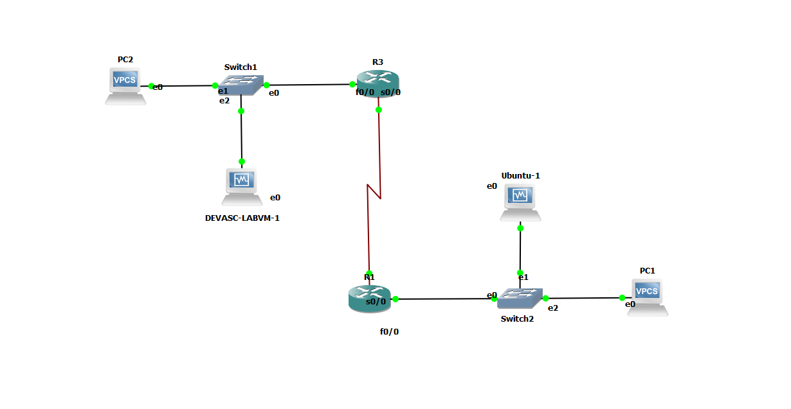

PART 1: Configuring the DEVASC-LABVM

- Open the DEVASC-LABVM and configure the SSH
              - Open the terminal and type the following command
devasc@labvm:~$ sudo nano ~/.ssh/config

              - Add the following lines to the ssh configuration
Host CSR*
Port 22
User cisco
StrictHostKeyChecking=no
UserKnownHostsFile=/dev/null
KexAlgorithms +diffie-hellman-group-exchange-sha1

Host *
Port 22
User cisco
StrictHostKeyChecking=no
UserKnownHostsFile=/dev/null
KexAlgorithms +diffie-hellman-group1-sha1
Ciphers +3des-cbc

SendEnv LANG LC_*
Ciphers +aes256-cbc

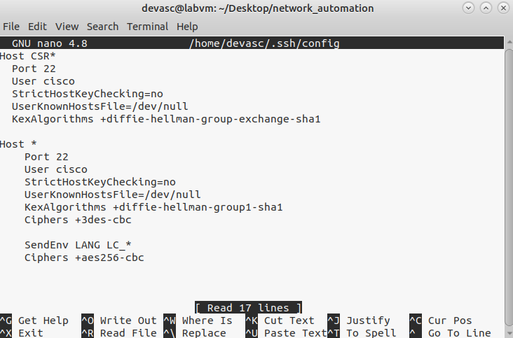

- Configure the NETPLAN
- Open the terminal and type the following command
devasc@labvm:~$ sudo nano /etc/netplan/01-netcfg.yaml
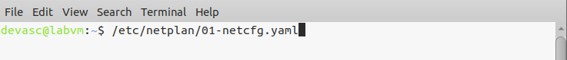

- Add the following lines to the netcfg.yaml
network:
version: 2
renderer: networkd
ethernets:
eth:
match:
name: en*
dhcp4: yes
enp0s3:
dhcp4: no
addresses:
- 192.168.1.2/24
gateway4: 192.168.1.1

bridges:
dummy0:
dhcp4: no
dhcp6: no
accept-ra: no
interfaces: [ ]
addresses:
- 192.0.2.1/32 # library.demo.local
- 192.0.2.2/32 # pt-controller.demo.local
- 192.0.2.3/32 # TBD
- 192.0.2.4/32 # TBD
192.0.2.5/32 # TBD

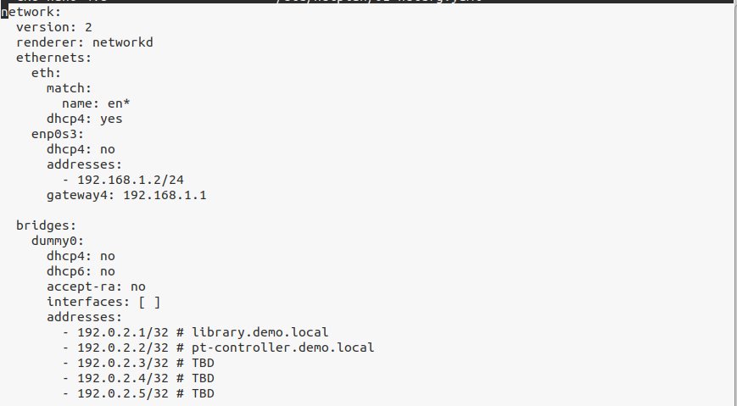

- Apply the following configuration
devasc@labvm:~$ sudo netplan apply

PART 2: Configuring the Ubuntu Machine

- Open the DEVASC-LABVM and configure the SSH
              - Open the terminal and type the following command
andylamzoned@andylamzoned-VirtualBox:~$ sudo nano ~/.ssh/config

  - Add the following lines to the ssh configuration
Host *
Port 22
User cisco
StrictHostKeyChecking=no
UserKnownHostsFile=/dev/null
KexAlgorithms +diffie-hellman-group1-sha1
Ciphers +3des-cbc

SendEnv LANG LC_*
Ciphers +aes256-cbc
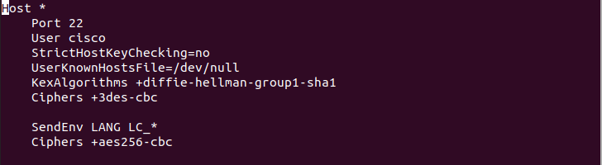

- Configure the NETPLAN
              - Open the terminal and type the following command
andylamzoned@andylamzoned-VirtualBox:~$ sudo nano /etc/netplan/01-netcfg.yaml

              - Add the following lines to the netcfg.yaml
network:
version: 2
renderer: networkd
ethernets:
eth:
match:
name: en*
dhcp4: yes
enp0s3:
dhcp4: no
addresses:
- 192.168.2.3/24
gateway4: 192.168.2.1

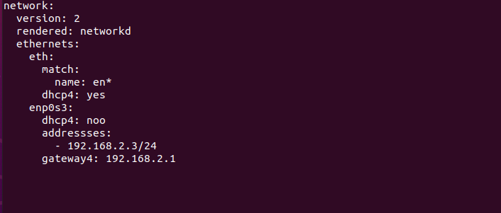

              - Apply the following configuration
andylamzoned@andylamzoned-VirtualBox:~$ sudo netplan apply

PART 3: Configuring Router 1 (R1) and Router 2 (R2)
- Show running-configuration of R1

Current configuration : 1830 bytes
!
version 12.4
service timestamps debug datetime msec
service timestamps log datetime msec
no service password-encryption
!
hostname R1
!
boot-start-marker
boot-end-marker
!
enable secret 5 $1$dod/$WXuWbs5zIdCZ5MzXp4XnQ.
!
no aaa new-model
memory-size iomem 5
no ip icmp rate-limit unreachable
ip cef
!
!
!
!
no ip domain lookup
ip domain name www.abc.com
!
multilink bundle-name authenticated
!
!
!
!
!
!
!
!
!
!
!
!
!
!
!
!
!
!
!
!
!
username cisco password 0 cisco123
archive
log config
hidekeys
!
!
!
!
ip tcp synwait-time 5
ip ssh version 2
!
!
!
!
interface FastEthernet0/0
ip address 192.168.1.1 255.255.255.252
ip access-group 110 in
duplex auto
speed auto
!
interface Serial0/0
ip address 10.0.0.1 255.255.255.252
clock rate 2000000
!
interface FastEthernet0/1
no ip address
shutdown
duplex auto
speed auto
!
interface Serial0/1
no ip address
shutdown
clock rate 2000000
!
interface Serial0/2
no ip address
shutdown
clock rate 2000000
!
interface FastEthernet1/0
no ip address
shutdown
duplex auto
speed auto
!
interface Serial2/0
no ip address
shutdown
serial restart-delay 0
!
interface Serial2/1
no ip address
shutdown
serial restart-delay 0
!
interface Serial2/2
no ip address
shutdown
serial restart-delay 0
!
interface Serial2/3
no ip address
shutdown
serial restart-delay 0
!
router ospf 1
log-adjacency-changes
network 0.0.0.0 255.255.255.255 area 0
!
ip forward-protocol nd
ip route 0.0.0.0 0.0.0.0 10.0.0.2
!
!
no ip http server

no ip http secure-server
!
no cdp log mismatch duplex
!
!
!
!
!
!
control-plane
!
!
!
!
!
!
!
!
!
!
line con 0
exec-timeout 0 0
privilege level 15
logging synchronous
line aux 0
exec-timeout 0 0
privilege level 15
logging synchronous
line vty 0 4
login local
transport input ssh
line vty 5 15
login local
transport input ssh
!
!
End

- Show running-configuration of R2
Current configuration : 1828 bytes
!
version 12.4
service timestamps debug datetime msec
service timestamps log datetime msec
no service password-encryption
!
hostname R2
!
boot-start-marker
boot-end-marker
!
enable secret 5 $1$EKLe$XeSxBV4laWRqm9vgsj9I7/
!
no aaa new-model
memory-size iomem 5
no ip icmp rate-limit unreachable
ip cef
!
!
!
!
no ip domain lookup
ip domain name www.abc.com
!
multilink bundle-name authenticated
!
!
!
!
!
!
!
!
!
!
!
!
!
!
!
!
!
!
!
!
!
username cisco password 0 cisco123
archive
log config
hidekeys
!
!
!
!
ip tcp synwait-time 5
ip ssh version 2
!
!
!
!
interface FastEthernet0/0
ip address 192.168.2.1 255.255.255.0
ip access-group 110 in
duplex auto
speed auto
!
interface Serial0/0
ip address 10.0.0.2 255.255.255.252
clock rate 2000000
!
interface FastEthernet0/1
no ip address
shutdown
duplex auto
speed auto
!
interface Serial0/1
no ip address
shutdown
clock rate 2000000
!
interface Serial0/2
no ip address
shutdown
clock rate 2000000
!
interface FastEthernet1/0
no ip address
shutdown
duplex auto
speed auto
!
interface Serial2/0
no ip address
shutdown
serial restart-delay 0
!
interface Serial2/1
no ip address
shutdown
serial restart-delay 0
!
interface Serial2/2
no ip address
shutdown
serial restart-delay 0
!
interface Serial2/3
no ip address
shutdown
serial restart-delay 0
!
router ospf 1
log-adjacency-changes
network 0.0.0.0 255.255.255.255 area 0
!
ip forward-protocol nd
ip route 0.0.0.0 0.0.0.0 10.0.0.1
!
!
no ip http server
no ip http secure-server
!
no cdp log mismatch duplex
!
!
!
!
!
!
control-plane
!
!
!
!
!
!
!
!
!
!
line con 0
exec-timeout 0 0
privilege level 15
logging synchronous
line aux 0
exec-timeout 0 0
privilege level 15
logging synchronous
line vty 0 4
login local
transport input ssh
line vty 5 15
login local
transport input ssh
!
!
End

PART 4: Testing the Connection to R1, R2, and Ubuntu

- DEVASC-LABVM to R1
  - Ping
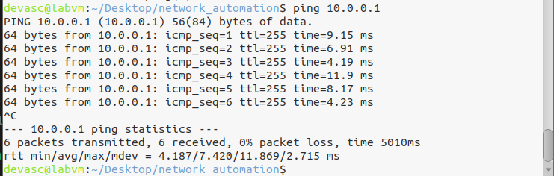

  - SSH

- DEVASC-LABVM to R2
  - Ping
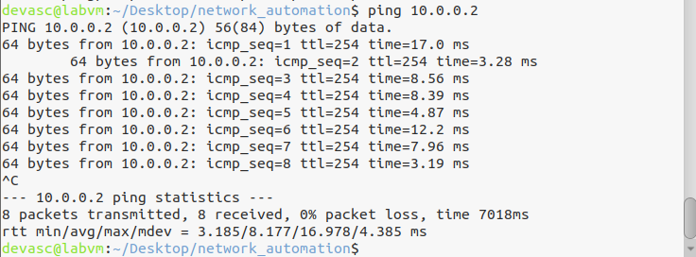

  - SSH
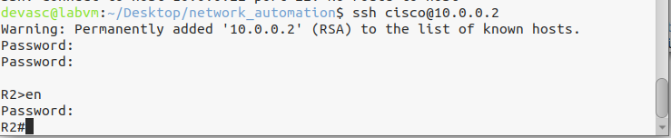

- DEVASC-LABVM to Ubuntu
  - Ping
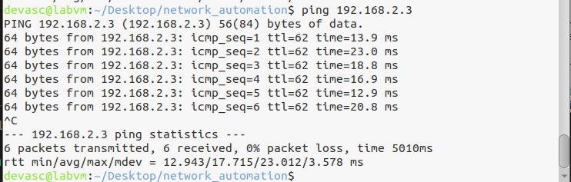

  - SSH
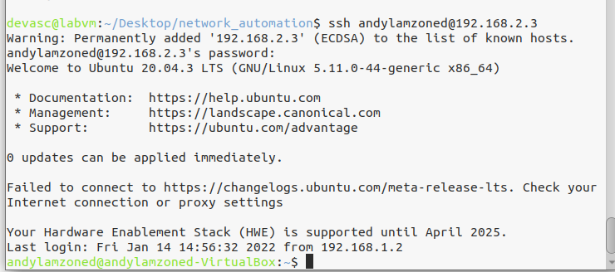

PART 5: Create ansible.cfg and hosts file for the Ansible Automation
Certain settings in Ansible are adjustable via a configuration file (ansible.cfg). The stock configuration should be sufficient for most users, but there may be reasons you would want to change them. Paths where configuration file is searched are listed

- Create ansible.cfg with your remote_user
[defaults]
inventory = ./hosts
host_key_checking = false
timeout = 15
deprecation_warnings=False
remote_user = andylamzoned
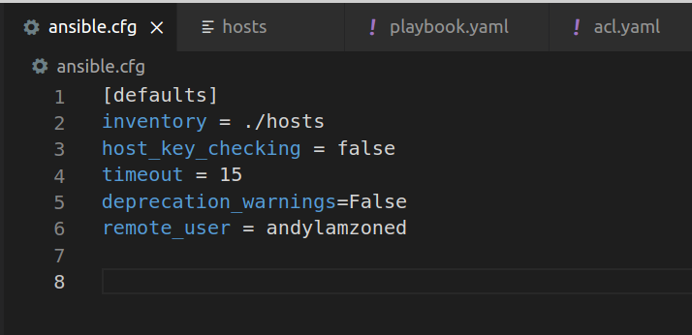

- Create a hosts file with correct host address, IP address, ssh password, and username.
[routers]
R1 ansible_host=10.0.0.1
R2 ansible_host=10.0.0.2

[routers:vars]
ansible_user=cisco
ansible_password=cisco123
ansible_connection=network_cli
ansible_network_os=ios
ansible_port=22
ansible_become=yes
ansible_become_method=enable
ansible_become_pass=cisco123

[ubuntu]
ubutnu_server ansible_host=192.168.2.3

[ubuntu:vars]
ansible_ssh_pass=cisco123
ansible_ssh_user=andylamzoned
ansible_password=cisco123
ansible_port=22
ansible_become=yes
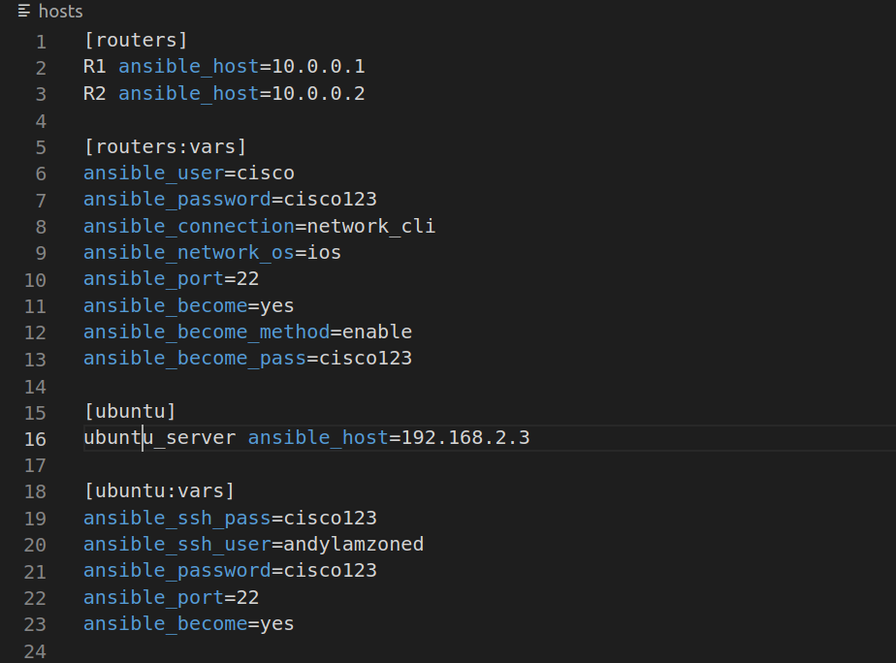

- Test the connectivity of all devices using the ansible ping.
devasc@labvm:~/Desktop/network_automation$ ansible all -m ping
R2 | SUCCESS => {
"ansible_facts": {
"discovered_interpreter_python": "/usr/bin/python3"
},
"changed": false,
"ping": "pong"
}
R1 | SUCCESS => {
"ansible_facts": {
"discovered_interpreter_python": "/usr/bin/python3"
},
"changed": false,
"ping": "pong"
}
ubuntu_server | SUCCESS => {
"ansible_facts": {
"discovered_interpreter_python": "/usr/bin/python3"
},
"changed": false,
"ping": "pong"
}
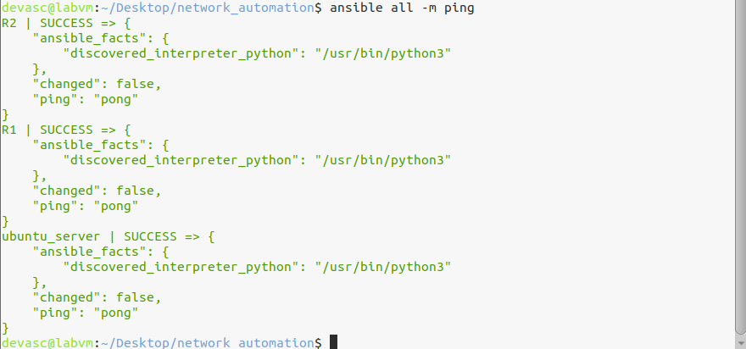

PART 6: Create a playbook that configures OSPF (Open Shortest Path First) to R1 and R2.

- Create a playbook named ospf.yaml
- Add the following lines to the playbook (ospf.yaml)
---
- name: Configure OSPF on R1
hosts: R1
gather_facts: false
connection: local

vars:
cli:
username: cisco
password: cisco123

tasks:
- name: Enable OSPF on R1
ios_config:
provider: "{{ cli }}"
authorize: yes
parents: router ospf 1
lines:
- network 0.0.0.0 255.255.255.255 area 0

register: print_output
- debug: var=print_output

- name: Configure OSPF on R2
hosts: R2
gather_facts: false
connection: local

vars:
cli:
username: cisco
password: cisco123

tasks:
- name: Enable OSPF on R2
ios_config:
provider: "{{ cli }}"
authorize: yes
parents: router ospf 1
lines:
- network 0.0.0.0 255.255.255.255 area 0

register: print_output
- debug: var=print_output

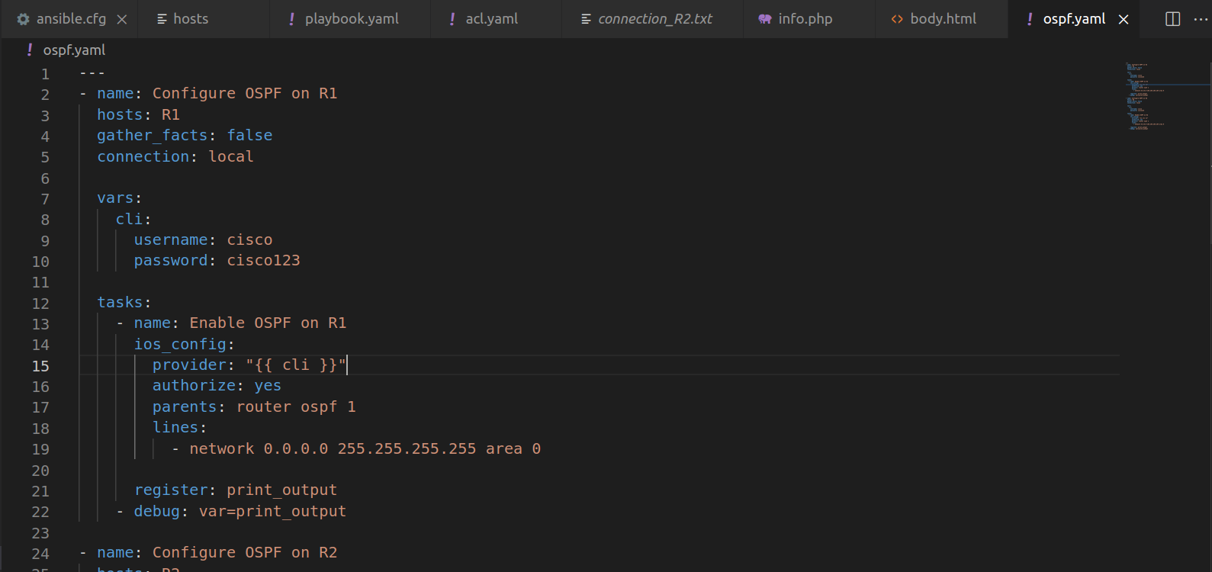

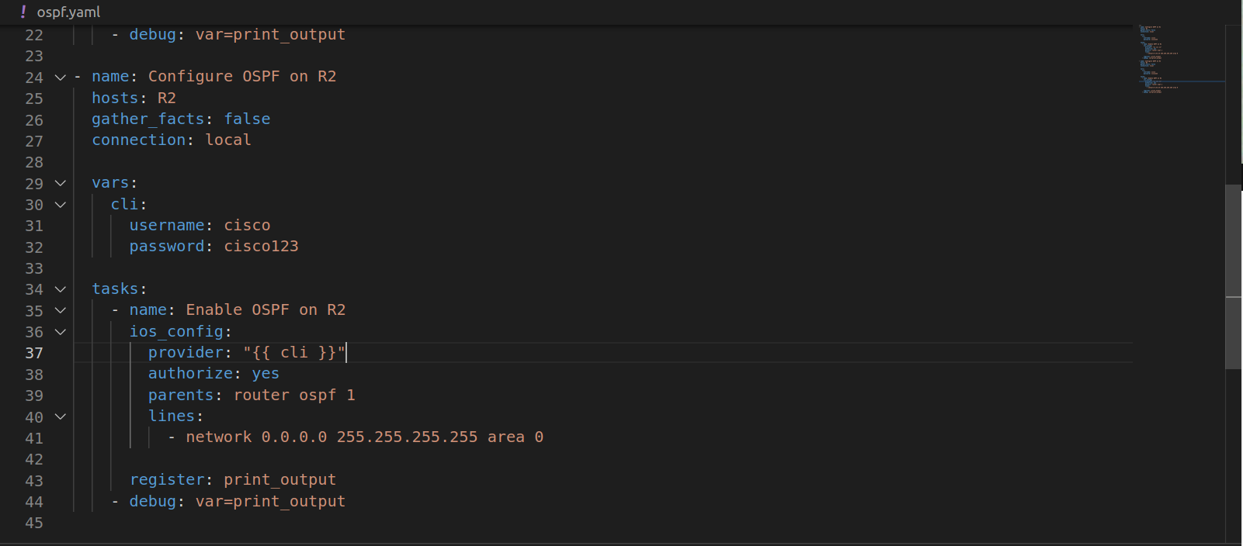

- Run the playbook
devasc@labvm:~/Desktop/network_automation$ ansible-playbook -v ospf.yaml
Using /home/devasc/Desktop/network_automation/ansible.cfg as config file

PLAY [Configure OSPF on R1] ********************************************************************

TASK [Enable OSPF on R1] ***********************************************************************
[WARNING]: provider is unnecessary when using network_cli and will be ignored
ok: [R1] => {"ansible_facts": {"discovered_interpreter_python": "/usr/bin/python3"}, "changed": false}

TASK [debug] ***********************************************************************************
ok: [R1] => {
"print_output": {
"ansible_facts": {
"discovered_interpreter_python": "/usr/bin/python3"
},
"changed": false,
"failed": false
}
}

PLAY [Configure OSPF on R2] ********************************************************************

TASK [Enable OSPF on R2] ***********************************************************************
[WARNING]: provider is unnecessary when using network_cli and will be ignored
ok: [R2] => {"ansible_facts": {"discovered_interpreter_python": "/usr/bin/python3"}, "changed": false}

TASK [debug] ***********************************************************************************
ok: [R2] => {
"print_output": {
"ansible_facts": {
"discovered_interpreter_python": "/usr/bin/python3"
},
"changed": false,
"failed": false
}
}

PLAY RECAP *************************************************************************************
R1 : ok=2 changed=0 unreachable=0 failed=0 skipped=0 rescued=0 ignored=0
R2 : ok=2 changed=0 unreachable=0 failed=0 skipped=0 rescued=0 ignored=0

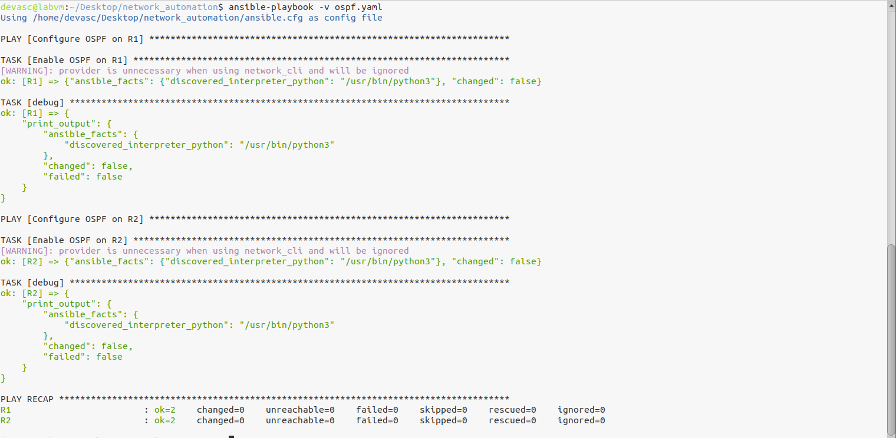

PART 7: Create a playbook that configures ACL (Access-control lists) inbound on R2 (Router 2)

- Create a playbook namedacl.yaml
- Add the following lines to the playbook (acl.yaml)
---
- name: Configuring the Access-Control Lists on R2
hosts: R2
gather_facts: false
connection: local

tasks:
- name: Configuring the port for ACL
ios_config:
lines:
- ip access-group 110 in
parents: interface FastEthernet0/0

- name: Create rules for Interface Fa0/0
ios_config:
lines:
- access-list 110 deny icmp any any echo-reply
- access-list 110 permit ip any any
before: no access-list 110
match: exact

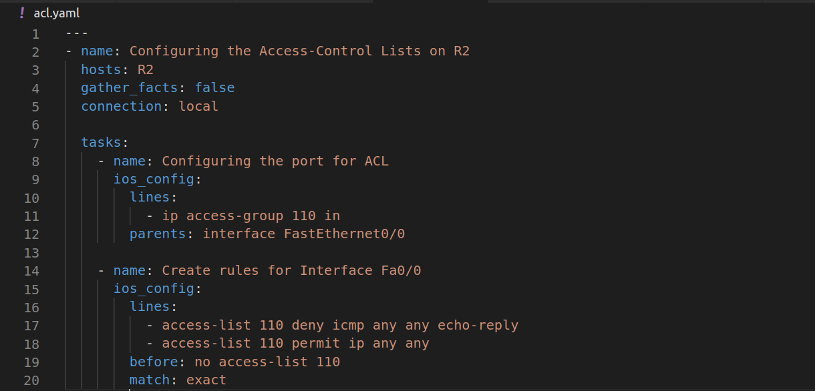

- Run the playbook (acl.yaml)

devasc@labvm:~/Desktop/network_automation$ ansible-playbook -v acl.yaml
Using /home/devasc/Desktop/network_automation/ansible.cfg as config file

PLAY [Configuring the Access-Control Lists on R2] *********************************************************************************************************************

TASK [Configuring the port for ACL] ***********************************************************************************************************************************
ok: [R2] => {"ansible_facts": {"discovered_interpreter_python": "/usr/bin/python3"}, "changed": false}

TASK [Create rules for Interface Fa0/0] *******************************************************************************************************************************
changed: [R2] => {"banners": {}, "changed": true, "commands": ["no access-list 110", "access-list 110 deny icmp any any echo-reply", "access-list 110 permit ip any any"], "updates": ["no access-list 110", "access-list 110 deny icmp any any echo-reply", "access-list 110 permit ip any any"]}

PLAY RECAP ************************************************************************************************************************************************************
R2 : ok=2 changed=1 unreachable=0 failed=0 skipped=0 rescued=0 ignored=0

devasc@labvm:~/Desktop/network_automation$

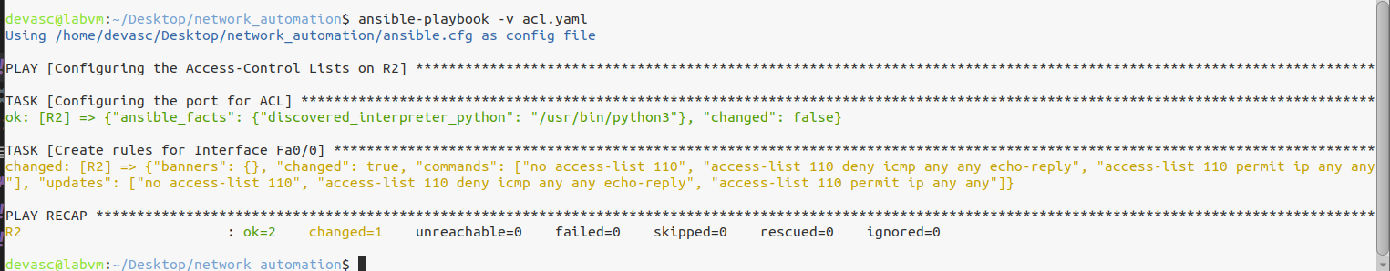

- Verify the ACL list for R2
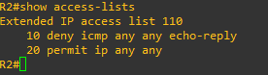

- Ping the Ubuntu server.
Note: DEVASC-LABVM won’t able to ping Ubuntu server because of ACL

PART 8: Install Apache2 on Ubuntu Virtual Machine

- Install the apache2 server
andylamzoned@andylamzoned-VirtualBox:~$ sudo apt-get install apache2

- Restart and enable the apache2 service
andylamzoned@andylamzoned-VirtualBox:~$ sudo systemctl restart apache
andylamzoned@andylamzoned-VirtualBox:~$ sudo system start apache2
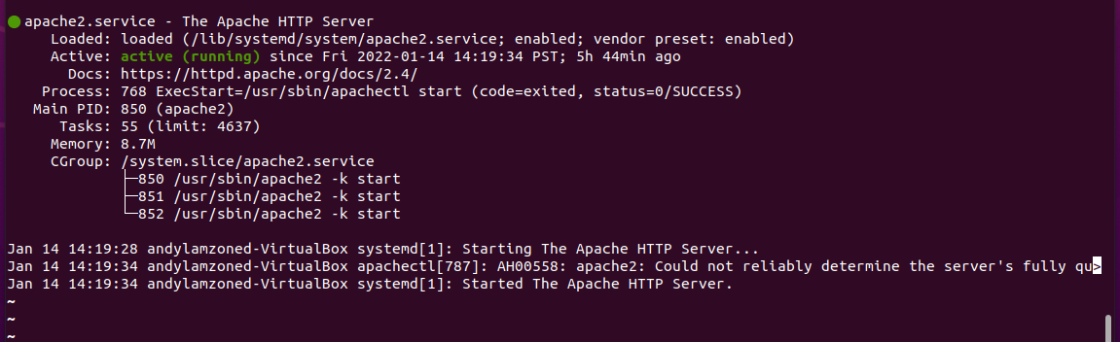

- Open a web browser and input the ubuntu’s IP address to URL box
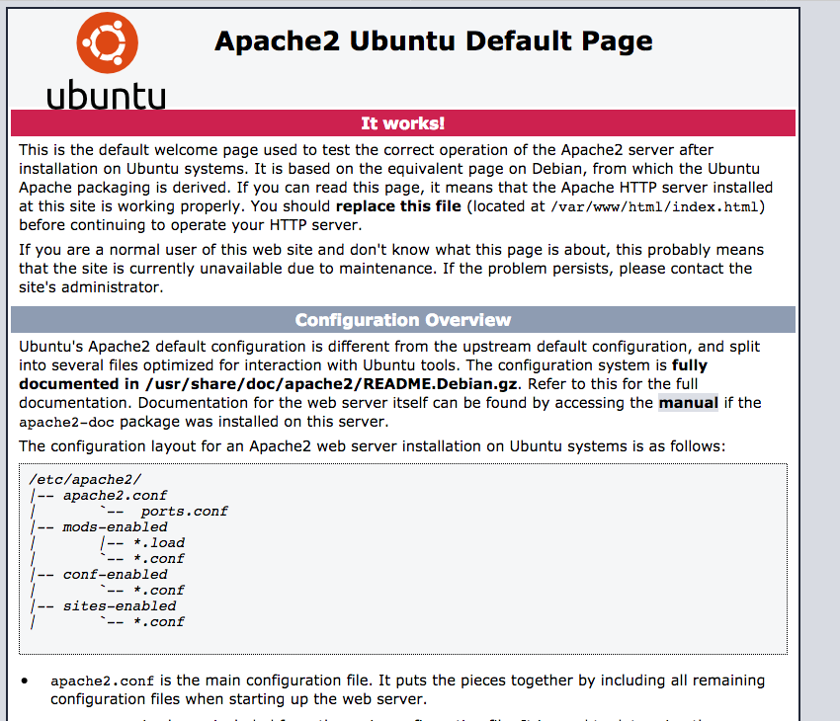

PART 9: Create a playbook that configure the webserver and add an index page
- Create an index.html
<title>jdlamzon-tip website</title>
<body>
<h1>DevOps Case Study</h1>

<p>This is the landing page of <strong>jdlamzon-tip</strong>
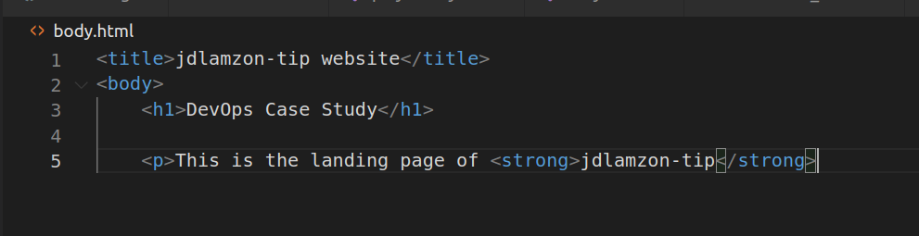

- Create an ansible playbook that configures the apache2 webserver and place the index.html to the apache2
---
- name: Installing Apache2 and Updating the Firewall
hosts: ubuntu

tasks:
- name: Install Apache
apt:
name: apache2
state: present

- name: start apache2 service
service:
name: apache2
state: started
enabled: yes

- name: Allow all access to TCP Port 80
ufw:
rule: allow
port: '80'
proto: tcp

- name: Enabled Firewall
ufw:
state: enabled

- name: Creating a virtual host in the website
hosts: ubuntu

tasks:
- name: html test file
copy:
src: ./body.html
dest: /var/www/html/index.html
owner: root
group: root
mode: '0644'
register: index

- name: start webservice
service:
name: apache2
state: restarted
enabled: yes
when: index.changed

- name: Allow access to tcp port 80
ufw:
rule: allow
port: '80'
proto: tcp

- name: reload ufw
ufw:
state: reloaded
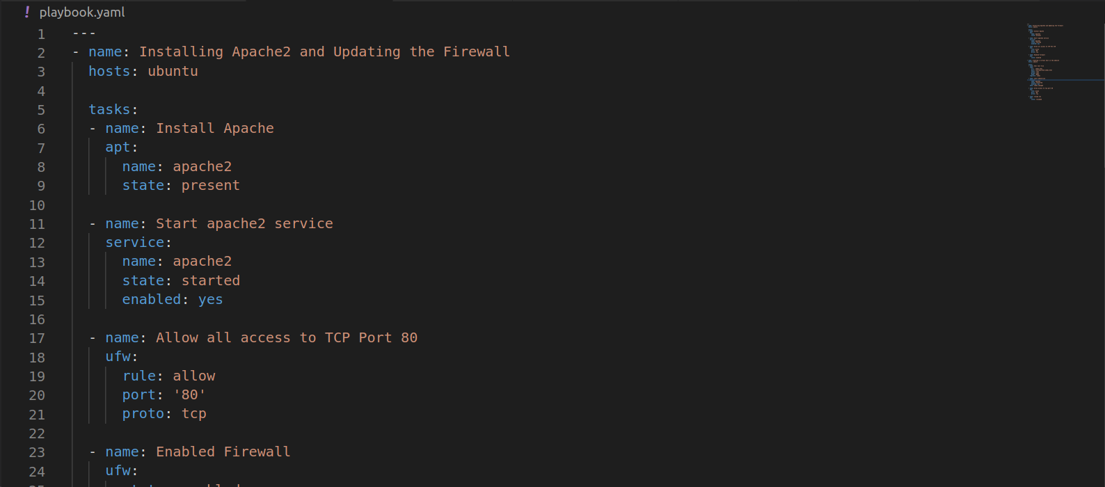

- Run the ansible playbook for the apache2 webserver
devasc@labvm:~/Desktop/network_automation$ ansible-playbook -v webserver.yaml
Using /home/devasc/Desktop/network_automation/ansible.cfg as config file

PLAY [Installing Apache2 and Updating the Firewall] *******************************************************************************************************************

TASK [Gathering Facts] ************************************************************************************************************************************************
ok: [ubuntu_server]

TASK [Install Apache] *************************************************************************************************************************************************
ok: [ubuntu_server] => {"cache_update_time": 1641795333, "cache_updated": false, "changed": false}

TASK [Start apache2 service] ******************************************************************************************************************************************
ok: [ubuntu_server] => {"changed": false, "enabled": true, "name": "apache2", "state": "started", "status": {"ActiveEnterTimestamp": "Fri 2022-01-14 20:08:44 PST", "ActiveEnterTimestampMonotonic": "20991604158", "ActiveExitTimestamp": "Fri 2022-01-14 20:08:44 PST", "ActiveExitTimestampMonotonic": "20991454005", "ActiveState": "active", "After": "-.mount sysinit.target systemd-journald.socket remote-fs.target nss-lookup.target systemd-tmpfiles-setup.service network.target basic.target system.slice", "AllowIsolate": "no", "AllowedCPUs": "", "AllowedMemoryNodes": "", "AmbientCapabilities": "", "AssertResult": "yes", "AssertTimestamp": "Fri 2022-01-14 20:08:44 PST", "AssertTimestampMonotonic": "20991577338", "Before": "shutdown.target multi-user.target", "BlockIOAccounting": "no", "BlockIOWeight": "[not set]", "CPUAccounting": "no", "CPUAffinity": "", "CPUAffinityFromNUMA": "no", "CPUQuotaPerSecUSec": "infinity", "CPUQuotaPeriodUSec": "infinity", "CPUSchedulingPolicy": "0", "CPUSchedulingPriority": "0", "CPUSchedulingResetOnFork": "no", "CPUShares": "[not set]", "CPUUsageNSec": "[not set]", "CPUWeight": "[not set]", "CacheDirectoryMode": "0755", "CanIsolate": "no", "CanReload": "yes", "CanStart": "yes", "CanStop": "yes", "CapabilityBoundingSet": "cap_chown cap_dac_override cap_dac_read_search cap_fowner cap_fsetid cap_kill cap_setgid cap_setuid cap_setpcap cap_linux_immutable cap_net_bind_service cap_net_broadcast cap_net_admin cap_net_raw cap_ipc_lock cap_ipc_owner cap_sys_module cap_sys_rawio cap_sys_chroot cap_sys_ptrace cap_sys_pacct cap_sys_admin cap_sys_boot cap_sys_nice cap_sys_resource cap_sys_time cap_sys_tty_config cap_mknod cap_lease cap_audit_write cap_audit_control cap_setfcap cap_mac_override cap_mac_admin cap_syslog cap_wake_alarm cap_block_suspend cap_audit_read 0x26 0x27 0x28", "CleanResult": "success", "CollectMode": "inactive", "ConditionResult": "yes", "ConditionTimestamp": "Fri 2022-01-14 20:08:44 PST", "ConditionTimestampMonotonic": "20991577337", "ConfigurationDirectoryMode": "0755", "Conflicts": "shutdown.target", "ControlGroup": "/system.slice/apache2.service", "ControlPID": "0", "DefaultDependencies": "yes", "DefaultMemoryLow": "0", "DefaultMemoryMin": "0", "Delegate": "no", "Description": "The Apache HTTP Server", "DevicePolicy": "auto", "Documentation": "https://httpd.apache.org/docs/2.4/", "DynamicUser": "no", "EffectiveCPUs": "", "EffectiveMemoryNodes": "", "Environment": "APACHE_STARTED_BY_SYSTEMD=true", "ExecMainCode": "0", "ExecMainExitTimestampMonotonic": "0", "ExecMainPID": "5106", "ExecMainStartTimestamp": "Fri 2022-01-14 20:08:44 PST", "ExecMainStartTimestampMonotonic": "20991604132", "ExecMainStatus": "0", "ExecReload": "{ path=/usr/sbin/apachectl ; argv[]=/usr/sbin/apachectl graceful ; ignore_errors=no ; start_time=[n/a] ; stop_time=[n/a] ; pid=0 ; code=(null) ; status=0/0 }", "ExecReloadEx": "{ path=/usr/sbin/apachectl ; argv[]=/usr/sbin/apachectl graceful ; flags= ; start_time=[n/a] ; stop_time=[n/a] ; pid=0 ; code=(null) ; status=0/0 }", "ExecStart": "{ path=/usr/sbin/apachectl ; argv[]=/usr/sbin/apachectl start ; ignore_errors=no ; start_time=[Fri 2022-01-14 20:08:44 PST] ; stop_time=[Fri 2022-01-14 20:08:44 PST] ; pid=5102 ; code=exited ; status=0 }", "ExecStartEx": "{ path=/usr/sbin/apachectl ; argv[]=/usr/sbin/apachectl start ; flags= ; start_time=[Fri 2022-01-14 20:08:44 PST] ; stop_time=[Fri 2022-01-14 20:08:44 PST] ; pid=5102 ; code=exited ; status=0 }", "ExecStop": "{ path=/usr/sbin/apachectl ; argv[]=/usr/sbin/apachectl stop ; ignore_errors=no ; start_time=[n/a] ; stop_time=[n/a] ; pid=0 ; code=(null) ; status=0/0 }", "ExecStopEx": "{ path=/usr/sbin/apachectl ; argv[]=/usr/sbin/apachectl stop ; flags= ; start_time=[n/a] ; stop_time=[n/a] ; pid=0 ; code=(null) ; status=0/0 }", "FailureAction": "none", "FileDescriptorStoreMax": "0", "FinalKillSignal": "9", "FragmentPath": "/lib/systemd/system/apache2.service", "GID": "[not set]", "GuessMainPID": "yes", "IOAccounting": "no", "IOReadBytes": "18446744073709551615", "IOReadOperations": "18446744073709551615", "IOSchedulingClass": "0", "IOSchedulingPriority": "0", "IOWeight": "[not set]", "IOWriteBytes": "18446744073709551615", "IOWriteOperations": "18446744073709551615", "IPAccounting": "no", "IPEgressBytes": "[no data]", "IPEgressPackets": "[no data]", "IPIngressBytes": "[no data]", "IPIngressPackets": "[no data]", "Id": "apache2.service", "IgnoreOnIsolate": "no", "IgnoreSIGPIPE": "yes", "InactiveEnterTimestamp": "Fri 2022-01-14 20:08:44 PST", "InactiveEnterTimestampMonotonic": "20991575967", "InactiveExitTimestamp": "Fri 2022-01-14 20:08:44 PST", "InactiveExitTimestampMonotonic": "20991579544", "InvocationID": "e093897431604f629e855626b6d84fa3", "JobRunningTimeoutUSec": "infinity", "JobTimeoutAction": "none", "JobTimeoutUSec": "infinity", "KeyringMode": "private", "KillMode": "control-group", "KillSignal": "15", "LimitAS": "infinity", "LimitASSoft": "infinity", "LimitCORE": "infinity", "LimitCORESoft": "0", "LimitCPU": "infinity", "LimitCPUSoft": "infinity", "LimitDATA": "infinity", "LimitDATASoft": "infinity", "LimitFSIZE": "infinity", "LimitFSIZESoft": "infinity", "LimitLOCKS": "infinity", "LimitLOCKSSoft": "infinity", "LimitMEMLOCK": "65536", "LimitMEMLOCKSoft": "65536", "LimitMSGQUEUE": "819200", "LimitMSGQUEUESoft": "819200", "LimitNICE": "0", "LimitNICESoft": "0", "LimitNOFILE": "524288", "LimitNOFILESoft": "1024", "LimitNPROC": "15457", "LimitNPROCSoft": "15457", "LimitRSS": "infinity", "LimitRSSSoft": "infinity", "LimitRTPRIO": "0", "LimitRTPRIOSoft": "0", "LimitRTTIME": "infinity", "LimitRTTIMESoft": "infinity", "LimitSIGPENDING": "15457", "LimitSIGPENDINGSoft": "15457", "LimitSTACK": "infinity", "LimitSTACKSoft": "8388608", "LoadState": "loaded", "LockPersonality": "no", "LogLevelMax": "-1", "LogRateLimitBurst": "0", "LogRateLimitIntervalUSec": "0", "LogsDirectoryMode": "0755", "MainPID": "5106", "MemoryAccounting": "yes", "MemoryCurrent": "5693440", "MemoryDenyWriteExecute": "no", "MemoryHigh": "infinity", "MemoryLimit": "infinity", "MemoryLow": "0", "MemoryMax": "infinity", "MemoryMin": "0", "MemorySwapMax": "infinity", "MountAPIVFS": "no", "MountFlags": "", "NFileDescriptorStore": "0", "NRestarts": "0", "NUMAMask": "", "NUMAPolicy": "n/a", "Names": "apache2.service", "NeedDaemonReload": "no", "Nice": "0", "NoNewPrivileges": "no", "NonBlocking": "no", "NotifyAccess": "none", "OOMPolicy": "stop", "OOMScoreAdjust": "0", "OnFailureJobMode": "replace", "Perpetual": "no", "PrivateDevices": "no", "PrivateMounts": "no", "PrivateNetwork": "no", "PrivateTmp": "yes", "PrivateUsers": "no", "ProtectControlGroups": "no", "ProtectHome": "no", "ProtectHostname": "no", "ProtectKernelLogs": "no", "ProtectKernelModules": "no", "ProtectKernelTunables": "no", "ProtectSystem": "no", "RefuseManualStart": "no", "RefuseManualStop": "no", "ReloadResult": "success", "RemainAfterExit": "no", "RemoveIPC": "no", "Requires": "-.mount sysinit.target system.slice", "RequiresMountsFor": "/var/tmp /tmp", "Restart": "on-abort", "RestartKillSignal": "15", "RestartUSec": "100ms", "RestrictNamespaces": "no", "RestrictRealtime": "no", "RestrictSUIDSGID": "no", "Result": "success", "RootDirectoryStartOnly": "no", "RuntimeDirectoryMode": "0755", "RuntimeDirectoryPreserve": "no", "RuntimeMaxUSec": "infinity", "SameProcessGroup": "no", "SecureBits": "0", "SendSIGHUP": "no", "SendSIGKILL": "yes", "Slice": "system.slice", "StandardError": "inherit", "StandardInput": "null", "StandardInputData": "", "StandardOutput": "journal", "StartLimitAction": "none", "StartLimitBurst": "5", "StartLimitIntervalUSec": "10s", "StartupBlockIOWeight": "[not set]", "StartupCPUShares": "[not set]", "StartupCPUWeight": "[not set]", "StartupIOWeight": "[not set]", "StateChangeTimestamp": "Fri 2022-01-14 20:08:44 PST", "StateChangeTimestampMonotonic": "20991604158", "StateDirectoryMode": "0755", "StatusErrno": "0", "StopWhenUnneeded": "no", "SubState": "running", "SuccessAction": "none", "SyslogFacility": "3", "SyslogLevel": "6", "SyslogLevelPrefix": "yes", "SyslogPriority": "30", "SystemCallErrorNumber": "0", "TTYReset": "no", "TTYVHangup": "no", "TTYVTDisallocate": "no", "TasksAccounting": "yes", "TasksCurrent": "55", "TasksMax": "4637", "TimeoutAbortUSec": "1min 30s", "TimeoutCleanUSec": "infinity", "TimeoutStartUSec": "1min 30s", "TimeoutStopUSec": "1min 30s", "TimerSlackNSec": "50000", "Transient": "no", "Type": "forking", "UID": "[not set]", "UMask": "0022", "UnitFilePreset": "enabled", "UnitFileState": "enabled", "UtmpMode": "init", "WantedBy": "multi-user.target", "WatchdogSignal": "6", "WatchdogTimestampMonotonic": "0", "WatchdogUSec": "0"}}

TASK [Allow all access to TCP Port 80] ********************************************************************************************************************************
ok: [ubuntu_server] => {"changed": false, "commands": ["/usr/sbin/ufw status verbose", "/usr/bin/grep -h '^### tuple' /lib/ufw/user.rules /lib/ufw/user6.rules /etc/ufw/user.rules /etc/ufw/user6.rules /var/lib/ufw/user.rules /var/lib/ufw/user6.rules", "/usr/sbin/ufw --version", "/usr/sbin/ufw allow from any to any port 80 proto tcp", "/usr/sbin/ufw status verbose", "/usr/bin/grep -h '^### tuple' /lib/ufw/user.rules /lib/ufw/user6.rules /etc/ufw/user.rules /etc/ufw/user6.rules /var/lib/ufw/user.rules /var/lib/ufw/user6.rules"], "msg": "Status: active\nLogging: on (low)\nDefault: deny (incoming), allow (outgoing), disabled (routed)\nNew profiles: skip\n\nTo Action From\n-- ------ ----\n22/tcp ALLOW IN Anywhere \n80/tcp ALLOW IN Anywhere \n22/tcp (v6) ALLOW IN Anywhere (v6) \n80/tcp (v6) ALLOW IN Anywhere (v6)"}

TASK [Enabled Firewall] ***********************************************************************************************************************************************
ok: [ubuntu_server] => {"changed": false, "commands": ["/usr/sbin/ufw status verbose", "/usr/bin/grep -h '^### tuple' /lib/ufw/user.rules /lib/ufw/user6.rules /etc/ufw/user.rules /etc/ufw/user6.rules /var/lib/ufw/user.rules /var/lib/ufw/user6.rules", "/usr/sbin/ufw -f enable", "/usr/sbin/ufw status verbose", "/usr/bin/grep -h '^### tuple' /lib/ufw/user.rules /lib/ufw/user6.rules /etc/ufw/user.rules /etc/ufw/user6.rules /var/lib/ufw/user.rules /var/lib/ufw/user6.rules"], "msg": "Status: active\nLogging: on (low)\nDefault: deny (incoming), allow (outgoing), disabled (routed)\nNew profiles: skip\n\nTo Action From\n-- ------ ----\n22/tcp ALLOW IN Anywhere \n80/tcp ALLOW IN Anywhere \n22/tcp (v6) ALLOW IN Anywhere (v6) \n80/tcp (v6) ALLOW IN Anywhere (v6)"}

PLAY [Creating a virtual host in the website] *************************************************************************************************************************

TASK [Gathering Facts] ************************************************************************************************************************************************
ok: [ubuntu_server]

TASK [html test file] *************************************************************************************************************************************************
changed: [ubuntu_server] => {"changed": true, "checksum": "89e58a460ccee6b4e9a1ccb35379eb2d773da876", "dest": "/var/www/html/index.html", "gid": 0, "group": "root", "md5sum": "4f978f45450f05cb521e37355d445e5a", "mode": "0644", "owner": "root", "size": 134, "src": "/home/andylamzoned/.ansible/tmp/ansible-tmp-1642162663.4826882-7128-133477494355315/source", "state": "file", "uid": 0}

TASK [start webservice] ***********************************************************************************************************************************************
changed: [ubuntu_server] => {"changed": true, "enabled": true, "name": "apache2", "state": "started", "status": {"ActiveEnterTimestamp": "Fri 2022-01-14 20:08:44 PST", "ActiveEnterTimestampMonotonic": "20991604158", "ActiveExitTimestamp": "Fri 2022-01-14 20:08:44 PST", "ActiveExitTimestampMonotonic": "20991454005", "ActiveState": "active", "After": "-.mount sysinit.target systemd-journald.socket remote-fs.target nss-lookup.target systemd-tmpfiles-setup.service network.target basic.target system.slice", "AllowIsolate": "no", "AllowedCPUs": "", "AllowedMemoryNodes": "", "AmbientCapabilities": "", "AssertResult": "yes", "AssertTimestamp": "Fri 2022-01-14 20:08:44 PST", "AssertTimestampMonotonic": "20991577338", "Before": "shutdown.target multi-user.target", "BlockIOAccounting": "no", "BlockIOWeight": "[not set]", "CPUAccounting": "no", "CPUAffinity": "", "CPUAffinityFromNUMA": "no", "CPUQuotaPerSecUSec": "infinity", "CPUQuotaPeriodUSec": "infinity", "CPUSchedulingPolicy": "0", "CPUSchedulingPriority": "0", "CPUSchedulingResetOnFork": "no", "CPUShares": "[not set]", "CPUUsageNSec": "[not set]", "CPUWeight": "[not set]", "CacheDirectoryMode": "0755", "CanIsolate": "no", "CanReload": "yes", "CanStart": "yes", "CanStop": "yes", "CapabilityBoundingSet": "cap_chown cap_dac_override cap_dac_read_search cap_fowner cap_fsetid cap_kill cap_setgid cap_setuid cap_setpcap cap_linux_immutable cap_net_bind_service cap_net_broadcast cap_net_admin cap_net_raw cap_ipc_lock cap_ipc_owner cap_sys_module cap_sys_rawio cap_sys_chroot cap_sys_ptrace cap_sys_pacct cap_sys_admin cap_sys_boot cap_sys_nice cap_sys_resource cap_sys_time cap_sys_tty_config cap_mknod cap_lease cap_audit_write cap_audit_control cap_setfcap cap_mac_override cap_mac_admin cap_syslog cap_wake_alarm cap_block_suspend cap_audit_read 0x26 0x27 0x28", "CleanResult": "success", "CollectMode": "inactive", "ConditionResult": "yes", "ConditionTimestamp": "Fri 2022-01-14 20:08:44 PST", "ConditionTimestampMonotonic": "20991577337", "ConfigurationDirectoryMode": "0755", "Conflicts": "shutdown.target", "ControlGroup": "/system.slice/apache2.service", "ControlPID": "0", "DefaultDependencies": "yes", "DefaultMemoryLow": "0", "DefaultMemoryMin": "0", "Delegate": "no", "Description": "The Apache HTTP Server", "DevicePolicy": "auto", "Documentation": "https://httpd.apache.org/docs/2.4/", "DynamicUser": "no", "EffectiveCPUs": "", "EffectiveMemoryNodes": "", "Environment": "APACHE_STARTED_BY_SYSTEMD=true", "ExecMainCode": "0", "ExecMainExitTimestampMonotonic": "0", "ExecMainPID": "5106", "ExecMainStartTimestamp": "Fri 2022-01-14 20:08:44 PST", "ExecMainStartTimestampMonotonic": "20991604132", "ExecMainStatus": "0", "ExecReload": "{ path=/usr/sbin/apachectl ; argv[]=/usr/sbin/apachectl graceful ; ignore_errors=no ; start_time=[n/a] ; stop_time=[n/a] ; pid=0 ; code=(null) ; status=0/0 }", "ExecReloadEx": "{ path=/usr/sbin/apachectl ; argv[]=/usr/sbin/apachectl graceful ; flags= ; start_time=[n/a] ; stop_time=[n/a] ; pid=0 ; code=(null) ; status=0/0 }", "ExecStart": "{ path=/usr/sbin/apachectl ; argv[]=/usr/sbin/apachectl start ; ignore_errors=no ; start_time=[Fri 2022-01-14 20:08:44 PST] ; stop_time=[Fri 2022-01-14 20:08:44 PST] ; pid=5102 ; code=exited ; status=0 }", "ExecStartEx": "{ path=/usr/sbin/apachectl ; argv[]=/usr/sbin/apachectl start ; flags= ; start_time=[Fri 2022-01-14 20:08:44 PST] ; stop_time=[Fri 2022-01-14 20:08:44 PST] ; pid=5102 ; code=exited ; status=0 }", "ExecStop": "{ path=/usr/sbin/apachectl ; argv[]=/usr/sbin/apachectl stop ; ignore_errors=no ; start_time=[n/a] ; stop_time=[n/a] ; pid=0 ; code=(null) ; status=0/0 }", "ExecStopEx": "{ path=/usr/sbin/apachectl ; argv[]=/usr/sbin/apachectl stop ; flags= ; start_time=[n/a] ; stop_time=[n/a] ; pid=0 ; code=(null) ; status=0/0 }", "FailureAction": "none", "FileDescriptorStoreMax": "0", "FinalKillSignal": "9", "FragmentPath": "/lib/systemd/system/apache2.service", "GID": "[not set]", "GuessMainPID": "yes", "IOAccounting": "no", "IOReadBytes": "18446744073709551615", "IOReadOperations": "18446744073709551615", "IOSchedulingClass": "0", "IOSchedulingPriority": "0", "IOWeight": "[not set]", "IOWriteBytes": "18446744073709551615", "IOWriteOperations": "18446744073709551615", "IPAccounting": "no", "IPEgressBytes": "[no data]", "IPEgressPackets": "[no data]", "IPIngressBytes": "[no data]", "IPIngressPackets": "[no data]", "Id": "apache2.service", "IgnoreOnIsolate": "no", "IgnoreSIGPIPE": "yes", "InactiveEnterTimestamp": "Fri 2022-01-14 20:08:44 PST", "InactiveEnterTimestampMonotonic": "20991575967", "InactiveExitTimestamp": "Fri 2022-01-14 20:08:44 PST", "InactiveExitTimestampMonotonic": "20991579544", "InvocationID": "e093897431604f629e855626b6d84fa3", "JobRunningTimeoutUSec": "infinity", "JobTimeoutAction": "none", "JobTimeoutUSec": "infinity", "KeyringMode": "private", "KillMode": "control-group", "KillSignal": "15", "LimitAS": "infinity", "LimitASSoft": "infinity", "LimitCORE": "infinity", "LimitCORESoft": "0", "LimitCPU": "infinity", "LimitCPUSoft": "infinity", "LimitDATA": "infinity", "LimitDATASoft": "infinity", "LimitFSIZE": "infinity", "LimitFSIZESoft": "infinity", "LimitLOCKS": "infinity", "LimitLOCKSSoft": "infinity", "LimitMEMLOCK": "65536", "LimitMEMLOCKSoft": "65536", "LimitMSGQUEUE": "819200", "LimitMSGQUEUESoft": "819200", "LimitNICE": "0", "LimitNICESoft": "0", "LimitNOFILE": "524288", "LimitNOFILESoft": "1024", "LimitNPROC": "15457", "LimitNPROCSoft": "15457", "LimitRSS": "infinity", "LimitRSSSoft": "infinity", "LimitRTPRIO": "0", "LimitRTPRIOSoft": "0", "LimitRTTIME": "infinity", "LimitRTTIMESoft": "infinity", "LimitSIGPENDING": "15457", "LimitSIGPENDINGSoft": "15457", "LimitSTACK": "infinity", "LimitSTACKSoft": "8388608", "LoadState": "loaded", "LockPersonality": "no", "LogLevelMax": "-1", "LogRateLimitBurst": "0", "LogRateLimitIntervalUSec": "0", "LogsDirectoryMode": "0755", "MainPID": "5106", "MemoryAccounting": "yes", "MemoryCurrent": "5693440", "MemoryDenyWriteExecute": "no", "MemoryHigh": "infinity", "MemoryLimit": "infinity", "MemoryLow": "0", "MemoryMax": "infinity", "MemoryMin": "0", "MemorySwapMax": "infinity", "MountAPIVFS": "no", "MountFlags": "", "NFileDescriptorStore": "0", "NRestarts": "0", "NUMAMask": "", "NUMAPolicy": "n/a", "Names": "apache2.service", "NeedDaemonReload": "no", "Nice": "0", "NoNewPrivileges": "no", "NonBlocking": "no", "NotifyAccess": "none", "OOMPolicy": "stop", "OOMScoreAdjust": "0", "OnFailureJobMode": "replace", "Perpetual": "no", "PrivateDevices": "no", "PrivateMounts": "no", "PrivateNetwork": "no", "PrivateTmp": "yes", "PrivateUsers": "no", "ProtectControlGroups": "no", "ProtectHome": "no", "ProtectHostname": "no", "ProtectKernelLogs": "no", "ProtectKernelModules": "no", "ProtectKernelTunables": "no", "ProtectSystem": "no", "RefuseManualStart": "no", "RefuseManualStop": "no", "ReloadResult": "success", "RemainAfterExit": "no", "RemoveIPC": "no", "Requires": "-.mount sysinit.target system.slice", "RequiresMountsFor": "/var/tmp /tmp", "Restart": "on-abort", "RestartKillSignal": "15", "RestartUSec": "100ms", "RestrictNamespaces": "no", "RestrictRealtime": "no", "RestrictSUIDSGID": "no", "Result": "success", "RootDirectoryStartOnly": "no", "RuntimeDirectoryMode": "0755", "RuntimeDirectoryPreserve": "no", "RuntimeMaxUSec": "infinity", "SameProcessGroup": "no", "SecureBits": "0", "SendSIGHUP": "no", "SendSIGKILL": "yes", "Slice": "system.slice", "StandardError": "inherit", "StandardInput": "null", "StandardInputData": "", "StandardOutput": "journal", "StartLimitAction": "none", "StartLimitBurst": "5", "StartLimitIntervalUSec": "10s", "StartupBlockIOWeight": "[not set]", "StartupCPUShares": "[not set]", "StartupCPUWeight": "[not set]", "StartupIOWeight": "[not set]", "StateChangeTimestamp": "Fri 2022-01-14 20:08:44 PST", "StateChangeTimestampMonotonic": "20991604158", "StateDirectoryMode": "0755", "StatusErrno": "0", "StopWhenUnneeded": "no", "SubState": "running", "SuccessAction": "none", "SyslogFacility": "3", "SyslogLevel": "6", "SyslogLevelPrefix": "yes", "SyslogPriority": "30", "SystemCallErrorNumber": "0", "TTYReset": "no", "TTYVHangup": "no", "TTYVTDisallocate": "no", "TasksAccounting": "yes", "TasksCurrent": "55", "TasksMax": "4637", "TimeoutAbortUSec": "1min 30s", "TimeoutCleanUSec": "infinity", "TimeoutStartUSec": "1min 30s", "TimeoutStopUSec": "1min 30s", "TimerSlackNSec": "50000", "Transient": "no", "Type": "forking", "UID": "[not set]", "UMask": "0022", "UnitFilePreset": "enabled", "UnitFileState": "enabled", "UtmpMode": "init", "WantedBy": "multi-user.target", "WatchdogSignal": "6", "WatchdogTimestampMonotonic": "0", "WatchdogUSec": "0"}}

TASK [Allow access to tcp port 80] ************************************************************************************************************************************
ok: [ubuntu_server] => {"changed": false, "commands": ["/usr/sbin/ufw status verbose", "/usr/bin/grep -h '^### tuple' /lib/ufw/user.rules /lib/ufw/user6.rules /etc/ufw/user.rules /etc/ufw/user6.rules /var/lib/ufw/user.rules /var/lib/ufw/user6.rules", "/usr/sbin/ufw --version", "/usr/sbin/ufw allow from any to any port 80 proto tcp", "/usr/sbin/ufw status verbose", "/usr/bin/grep -h '^### tuple' /lib/ufw/user.rules /lib/ufw/user6.rules /etc/ufw/user.rules /etc/ufw/user6.rules /var/lib/ufw/user.rules /var/lib/ufw/user6.rules"], "msg": "Status: active\nLogging: on (low)\nDefault: deny (incoming), allow (outgoing), disabled (routed)\nNew profiles: skip\n\nTo Action From\n-- ------ ----\n22/tcp ALLOW IN Anywhere \n80/tcp ALLOW IN Anywhere \n22/tcp (v6) ALLOW IN Anywhere (v6) \n80/tcp (v6) ALLOW IN Anywhere (v6)"}

TASK [reload ufw] *****************************************************************************************************************************************************
changed: [ubuntu_server] => {"changed": true, "commands": ["/usr/sbin/ufw status verbose", "/usr/bin/grep -h '^### tuple' /lib/ufw/user.rules /lib/ufw/user6.rules /etc/ufw/user.rules /etc/ufw/user6.rules /var/lib/ufw/user.rules /var/lib/ufw/user6.rules", "/usr/sbin/ufw -f reload", "/usr/sbin/ufw status verbose"], "msg": "Status: active\nLogging: on (low)\nDefault: deny (incoming), allow (outgoing), disabled (routed)\nNew profiles: skip\n\nTo Action From\n-- ------ ----\n22/tcp ALLOW IN Anywhere \n80/tcp ALLOW IN Anywhere \n22/tcp (v6) ALLOW IN Anywhere (v6) \n80/tcp (v6) ALLOW IN Anywhere (v6)"}

PLAY RECAP ************************************************************************************************************************************************************
ubuntu_server : ok=10 changed=3 unreachable=0 failed=0 skipped=0 rescued=0 ignored=0

devasc@labvm:~/Desktop/network_automation$

- Verify the apache2 webserver using the DEVASC-LABVM

PART 10: Downlooad the pyATS and genie to test the network

- Create a pyats directory and change to that directory.
devasc@labvm:~/Desktop/network_automation$ mkdir pyats
devasc@labvm:~/Desktop/network_automation$ cd pyats
devasc@labvm:~/Desktop/network_automation/pyats$

- Create a new Python virtual environment in the pyats directory.
c

- Launch the virtual environment using bin/activate. All the commands done from this point on are within this venv.
devasc@labvm:~/Desktop/network_automation/pyats$ source bin/activate
(pyats) devasc@labvm:~/Desktop/network_automation/pyats$

- Install pyATS using pip3. This will take a few minutes. During installation you may see some errors. These can usually be ignored as long as pyATS can be verified as shown in the next step.
(pyats) devasc@labvm:~/Desktop/network_automation/pyats$ pip3 install pyats[full]
Collecting pyats[full]
Downloading pyats-20.4-cp38-cp38-manylinux1_x86_64.whl (2.0 MB)

<output omitted>

PART 11: Use the pyATS and Genie to test the Network
To create your testbed YAML file, enter the command below. The --output parameter will create a testbed.yml file in a directory named yaml. The directory will be automatically created. The --encode-password parameter will encode the passwords in the YAML file. The parameter interactive means you will be asked a series of questions. Answer no to the first three questions. And then provide the following answers to create the testbed.yaml file.
- Device hostname - This must match the hostname of the device.
- IP address - This must match your CSR1kv IPv4 address you discovered earlier in this lab.
- Username - This is the local username used for ssh.
- Default password - This is the local password used for ssh.
- Enable password - Leave blank. There is no privileged password configured on the router.
- Protocol - SSH along with the key exchange group expected by the router.
- OS - The OS on the router.

- Create a testbed that test the connectivity for the routers R1 and R2.
(pyats) devasc@labvm:~/Desktop/network_automation/pyats$ genie create testbed interactive –output testbed.yaml
(pyats) devasc@labvm:~/Desktop/network_automation/pyats$ genie create testbed interactive --output testbed.yaml
Start creating Testbed yaml file ...
Do all of the devices have the same username? [y/n] y
Common Username: cisco

Do all of the devices have the same default password? [y/n] y
Common Default Password (leave blank if you want to enter on demand):

Do all of the devices have the same enable password? [y/n] y
Common Enable Password (leave blank if you want to enter on demand):

Device hostname: R1
IP (ip, or ip:port): 10.0.0.1
Protocol (ssh, telnet, ...): ssh
OS (iosxr, iosxe, ios, nxos, linux, ...): ios
More devices to add ? [y/n] y

Device hostname: R2
IP (ip, or ip:port): 10.0.0.2
Protocol (ssh, telnet, ...): ssh
OS (iosxr, iosxe, ios, nxos, linux, ...): ios
More devices to add ? [y/n] n
Testbed file generated:
testbed.yaml
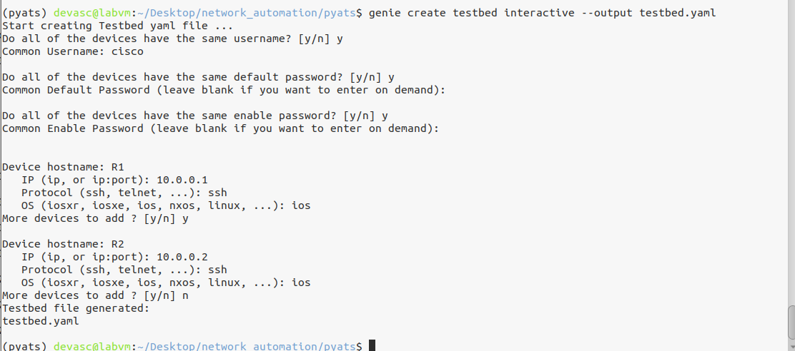

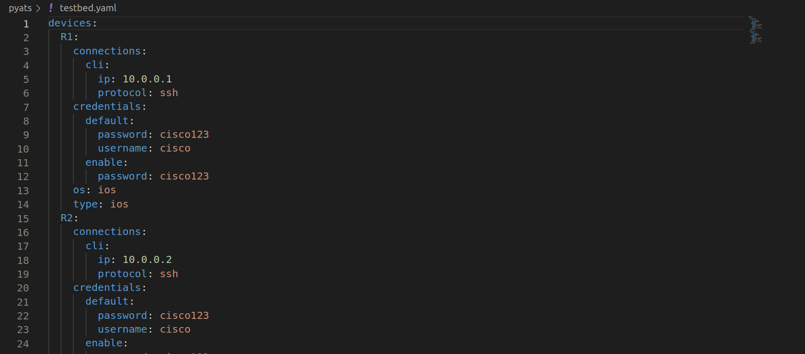

- Using the testbed YAML file, invoke Genie to parse unstructured output from the show ip interface brief command into structured JSON
(pyats) devasc@labvm:~/Desktop/network_automation/pyats$ genie parse "show ip interface brief" --testbed-file testbed.yaml
0%| | 0/1 [00:00<?, ?it/s]{
"interface": {
"FastEthernet0/0": {
"interface_is_ok": "YES",
"ip_address": "192.168.1.1",
"method": "manual",
"protocol": "up",
"status": "up"
},
"FastEthernet0/1": {
"interface_is_ok": "YES",
"ip_address": "unassigned",
"method": "unset",
"protocol": "down",
"status": "administratively down"
},
"FastEthernet1/0": {
"interface_is_ok": "YES",
"ip_address": "unassigned",
"method": "unset",
"protocol": "down",
"status": "administratively down"
},
"Serial0/0": {
"interface_is_ok": "YES",
"ip_address": "10.0.0.1",
"method": "manual",
"protocol": "up",
"status": "up"
},
"Serial0/1": {
"interface_is_ok": "YES",
"ip_address": "unassigned",
"method": "unset",
"protocol": "down",
"status": "administratively down"
},
"Serial0/2": {
"interface_is_ok": "YES",
"ip_address": "unassigned",
"method": "unset",
"protocol": "down",
"status": "administratively down"
},
"Serial2/0": {
"interface_is_ok": "YES",
"ip_address": "unassigned",
"method": "unset",
"protocol": "down",
"status": "administratively down"
},
"Serial2/1": {
"interface_is_ok": "YES",
"ip_address": "unassigned",
"method": "unset",
"protocol": "down",
"status": "administratively down"
},
"Serial2/2": {
"interface_is_ok": "YES",
"ip_address": "unassigned",
"method": "unset",
"protocol": "down",
"status": "administratively down"
},
"Serial2/3": {
"interface_is_ok": "YES",
"ip_address": "unassigned",
"method": "unset",
"protocol": "down",
"status": "administratively down"
}
}
}
100%|█████████████████████████████████████████████████████████████████████████████████████████████████| 1/1 [00:01<00:00, 1.26s/it]
0%| | 0/1 [00:00<?, ?it/s]{
"interface": {
"FastEthernet0/0": {
"interface_is_ok": "YES",
"ip_address": "192.168.2.1",
"method": "manual",
"protocol": "up",
"status": "up"
},
"FastEthernet0/1": {
"interface_is_ok": "YES",
"ip_address": "unassigned",
"method": "unset",
"protocol": "down",
"status": "administratively down"
},
"FastEthernet1/0": {
"interface_is_ok": "YES",
"ip_address": "unassigned",
"method": "unset",
"protocol": "down",
"status": "administratively down"
},
"Serial0/0": {
"interface_is_ok": "YES",
"ip_address": "10.0.0.2",
"method": "manual",
"protocol": "up",
"status": "up"
},
"Serial0/1": {
"interface_is_ok": "YES",
"ip_address": "unassigned",
"method": "unset",
"protocol": "down",
"status": "administratively down"
},
"Serial0/2": {
"interface_is_ok": "YES",
"ip_address": "unassigned",
"method": "unset",
"protocol": "down",
"status": "administratively down"
},
"Serial2/0": {
"interface_is_ok": "YES",
"ip_address": "unassigned",
"method": "unset",
"protocol": "down",
"status": "administratively down"
},
"Serial2/1": {
"interface_is_ok": "YES",
"ip_address": "unassigned",
"method": "unset",
"protocol": "down",
"status": "administratively down"
},
"Serial2/2": {
"interface_is_ok": "YES",
"ip_address": "unassigned",
"method": "unset",
"protocol": "down",
"status": "administratively down"
},
"Serial2/3": {
"interface_is_ok": "YES",
"ip_address": "unassigned",
"method": "unset",
"protocol": "down",
"status": "administratively down"
}
}
}
100%|█████████████████████████████████████████████████████████████████████████████████████████████████| 1/1 [00:00<00:00, 1.96it/s]

(pyats) devasc@labvm:~/Desktop/network_automation/pyats$
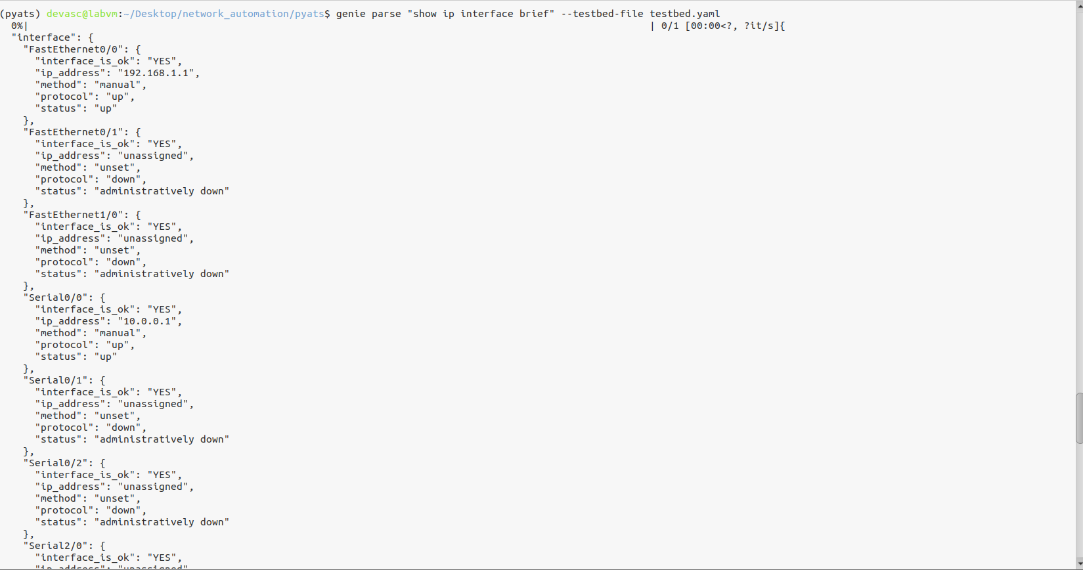

- Use the Genie learn to learn the configuration of the router. In this case, the genie will parse and learn the OSPF and ACL configured to each router.
  - OSPF
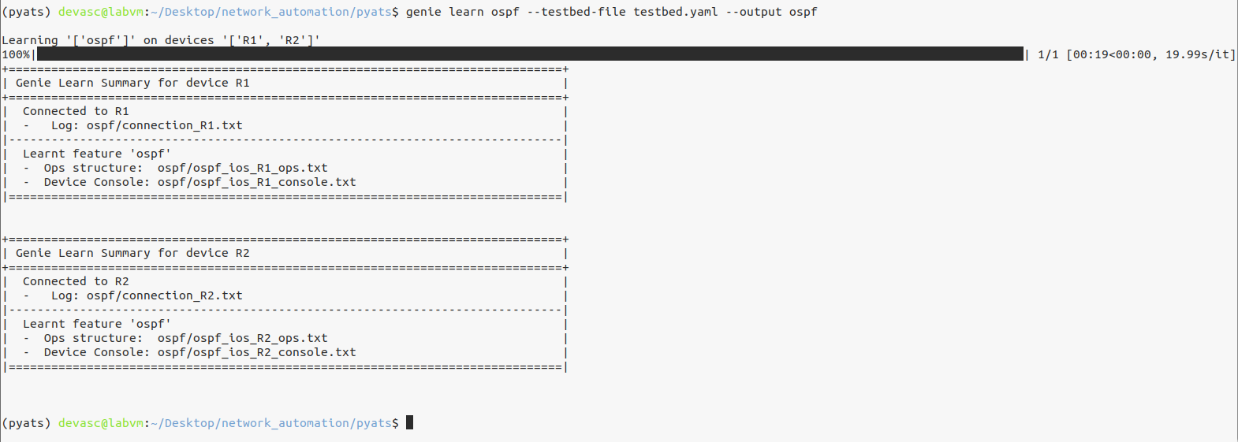
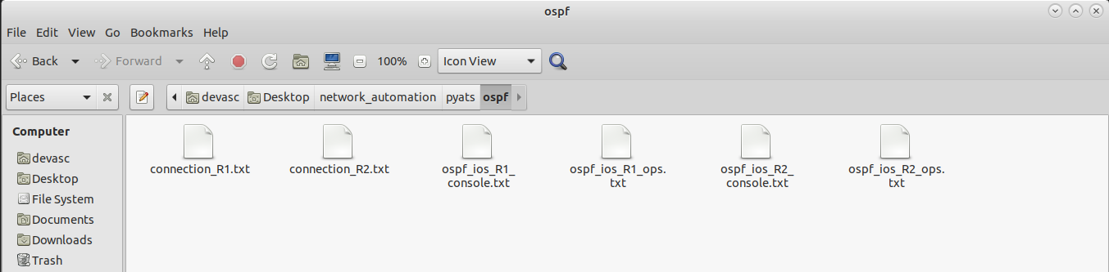

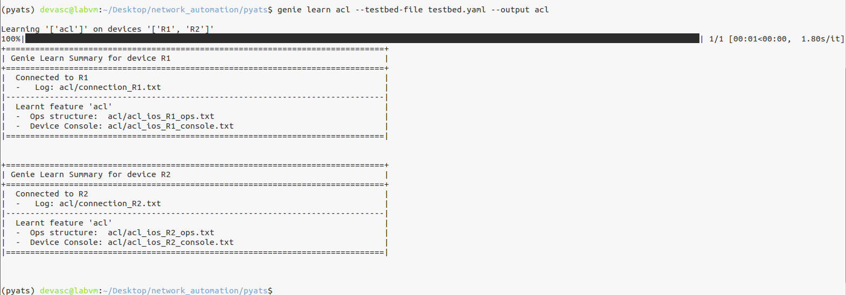
  - ACL

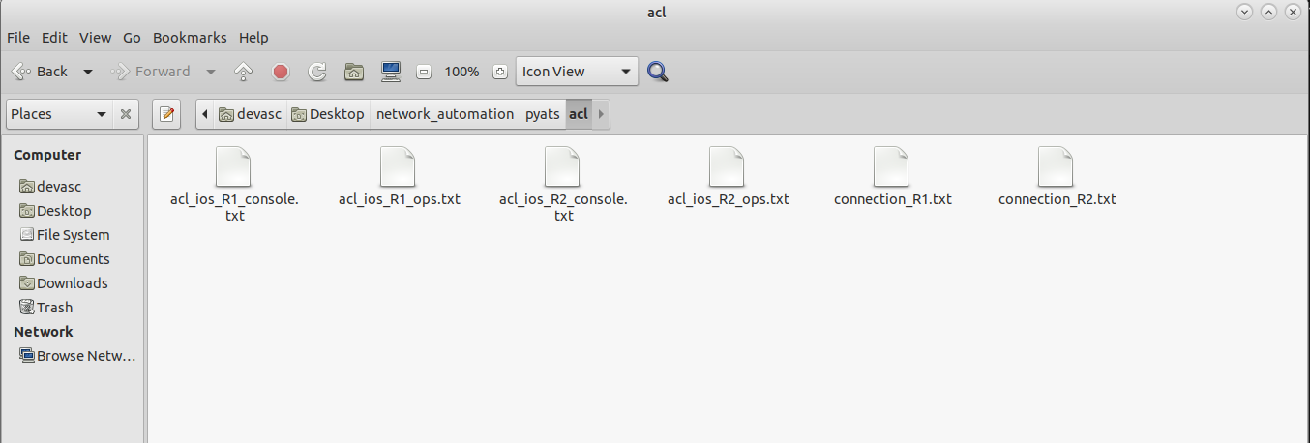

PART 12: Use the pyATS and Genie to test the Ubuntu Webserver
To create your testbed YAML file, enter the command below. The --output parameter will create a testbed.yml file in a directory named yaml. The directory will be automatically created. The --encode-password parameter will encode the passwords in the YAML file. The parameter interactive means you will be asked a series of questions. Answer no to the first three questions. And then provide the following answers to create the testbed.yaml file.
- Device hostname - This must match the hostname of the device.
- IP address - This must match your CSR1kv IPv4 address you discovered earlier in this lab.
- Username - This is the local username used for ssh.
- Default password - This is the local password used for ssh.
- Enable password - Leave blank. There is no privileged password configured on the router.
- Protocol - SSH along with the key exchange group expected by the router.
- OS - The OS on the router.

- Create a testbed that test the ubuntu webserver
genie parse "ifconfig" --testbed-file ubuntu_testbed.yaml --output ubuntu_ifconfig
